Java Script Crash Course
JavaScript is single-threaded and asynchronous. This means JavaScript executes its code on a single main thread, one operation at a time, but it does not have to block while waiting for certain asynchronous operations, such as network requests, timers, or file I/O. The runtime environment can handle these operations separately, allowing JavaScript to continue executing other code.
These are two different ways of writing JavaScript code.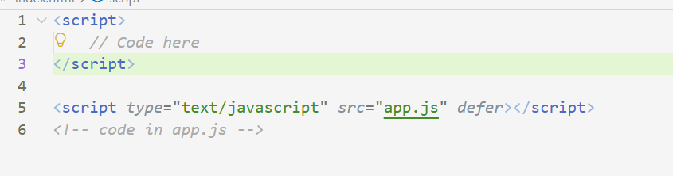

JavaScript has three ways to declare variables: var, let, and const. In modern JavaScript, we mostly use let and const. let allows us to declare a variable whose value can be reassigned later, while const does not allow reassignment after initialization. To print a variable's value to the console, we use console.log(variableName).
Example:-
let age = 25;
age = 26; // Allowed

const name = "Prajyot";
// name = "John"; // Error

console.log(age);
console.log(name);
Rules for Variable Names
- Must start with a letter, _, or $
- Cannot start with a number
- Can contain only letters, numbers, _, and $
- Cannot contain spaces or hyphens (-)
- Cannot use JavaScript reserved keywords
- Variable names are case-sensitive (name and Name are different)

JavaScript has several data types, including String, Number, Boolean, Array, Object, null, and undefined.
- String → text, e.g. "Hello"
- Number → integers and decimal numbers, e.g. 23, 34.354
- Boolean → true or false
- Array → an ordered collection of values, written using square brackets []
- Object → groups related information using key-value pairs
- null → explicitly represents the absence of a value
- undefined → a variable exists but has not been assigned a value

Example of an array:
let arr = [23, "hi", 34.354, true];

console.log(arr[0]); // 23
arr.push("hello"); // Adds value at the end
console.log(arr.length); // 5

Example of Object data type:-
const person = {
name: "Alice",
age: 25,
isStudent: true
};
console.log(person.name);

A function is a reusable block of code that performs a specific task. We can pass different types of values to a function as arguments, including numbers, strings, arrays, objects, and Boolean values. The function can then use these values to perform some operation and optionally return a result.
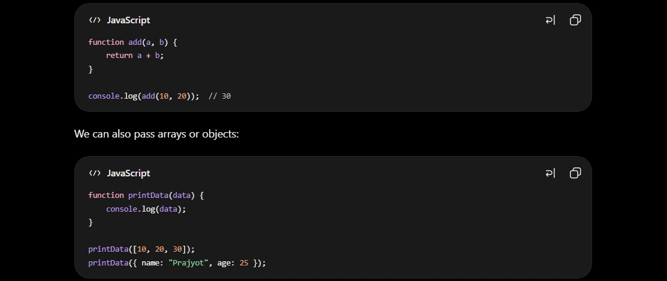

JavaScript supports the standard if, else if, and else conditional statements, which are used to execute different blocks of code depending on whether conditions are true or false.

JavaScript supports common loops such as for, while, and do...while, which are used to repeatedly execute a block of code. JavaScript arrays use zero-based indexing, meaning the first element is at index 0.
forEach() is an array method used to execute a callback function once for each element in an array.
Basic syntax:-
array.forEach((element) => {
// code to execute
});
The elements of an array can be values of different types, including numbers, strings, objects, other arrays, and even functions.
Example 1:-
names.forEach(printName);
function printName(name) {
console.log("My name is: " + name);
}
Example 2:-
let arr = [10, 20, 30, 40];
arr.forEach(function(value, index) {
console.log(index, value);
});

JavaScript has asynchronous behavior, which means that when certain operations take time to complete—such as network requests, timers, or file operations—JavaScript does not necessarily wait for them to finish before executing other code. Instead, it can continue executing the next statements and handle the result of the asynchronous operation when it becomes available.
Example:-
console.log("Start"); - Running 1st
setTimeout(() => {
console.log("This runs after 2 seconds"); - Running 3rd
}, 2000);
console.log("End"); - Running 2nd

Arrow functions:- An arrow function is a shorter and more concise way to write a function in JavaScript. It is especially useful for small functions and callbacks.
The basic structure is:-
const functionName = (parameters) => {
// function body
};
Example:-
const add = (a, b) => {
return a + b;
};
console.log(add(3, 4));

If the function has only one expression to return, you can remove {} and return:
const add = (a, b) => a + b;
console.log(add(3, 4)); // 7

JavaScript supports the common operators we use for arithmetic, comparison, assignment, and logical operations.
Common comparison operators:
== Equal (allows type conversion)
=== Strictly equal (value + type)
!= Not equal
!== Strictly not equal
> Greater than
< Less than
>= Greater than or equal
<= Less than or equal

Logical operators:-
&& → AND → both conditions must be true
|| → OR → at least one condition must be true
! → NOT → reverses true ↔ false

Using it in normal workflow ( simple ):-
<!DOCTYPE html>
<html>
<head>
<title>JS Basics</title>
</head>
<body>
<button onclick="sayHello()" id="myButton">Click Me</button>
<script>
let myButton = document.getElementById("myButton");
function sayHello() {
myButton.textContent = "Hello";
}
</script>
</body>
</html>

let myButton = document.getElementById('myButton');
- document.getElementById() finds the HTML element whose id is "myButton".
- myButton now refers to that button, so JavaScript can modify it.

function sayHello() {
myButton.textContent = "Hello";
}
- Defines a function called sayHello().
- When called, it changes the button's text using .textContent.

